MINIPROJECT

INSTAGRAM

SUGGESTED CHANGES:

* Replace all Thread.sleep with Implicit/Explicit wait:

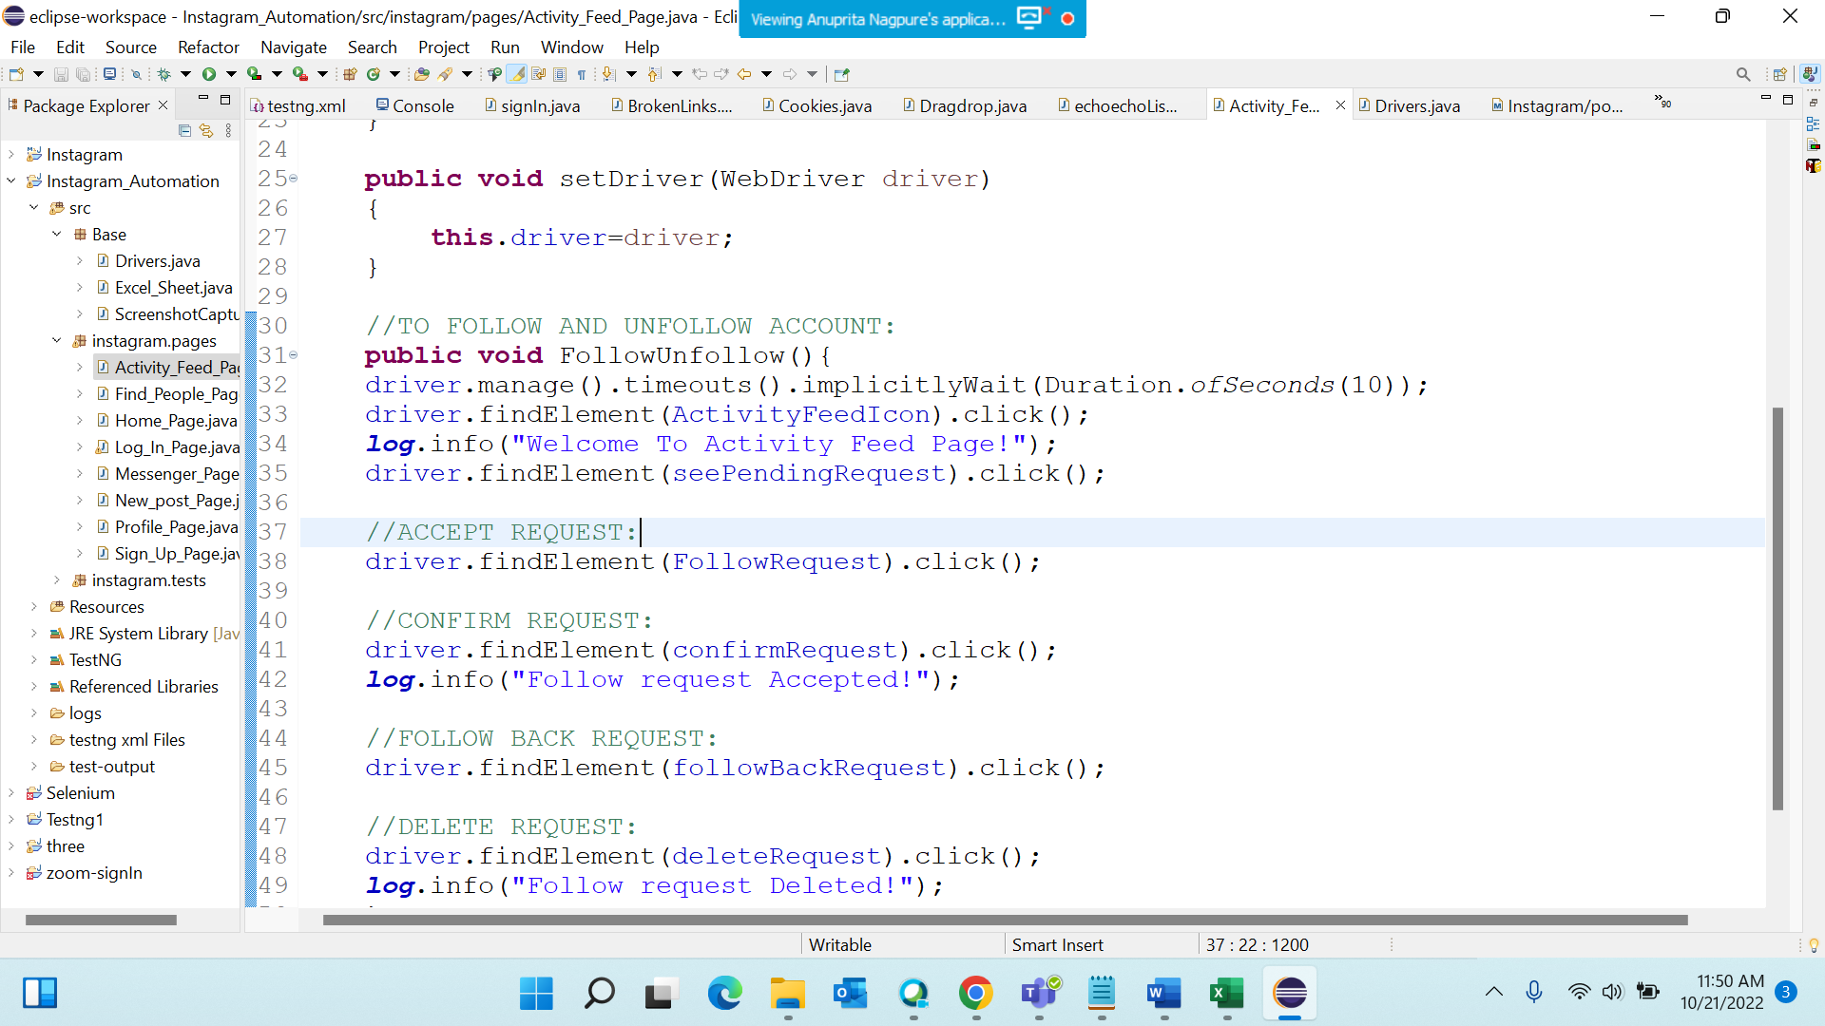

* Use try-catch block instead of throws and Take screenshot of error:

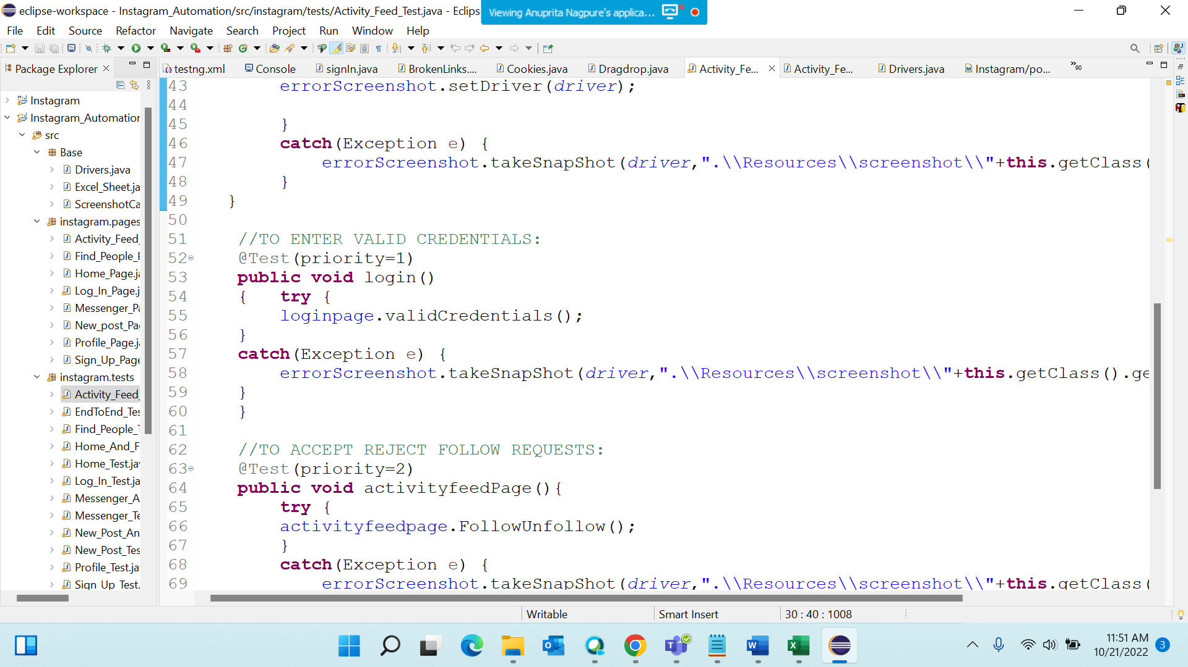

* Use log4j:

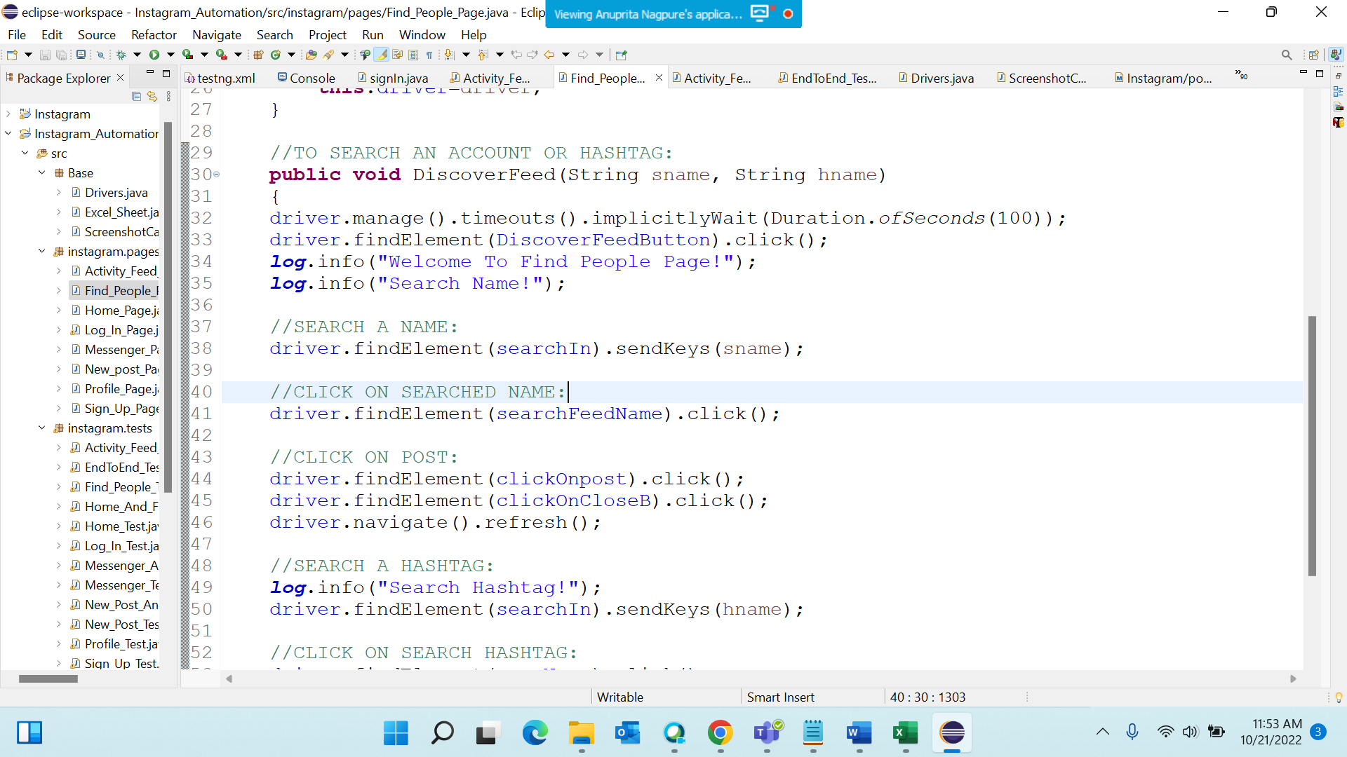

* Replaced System.setProperty() with WebDriverManager:

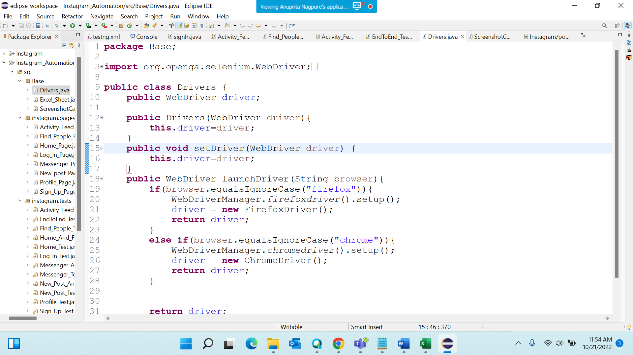

* Add Comments:

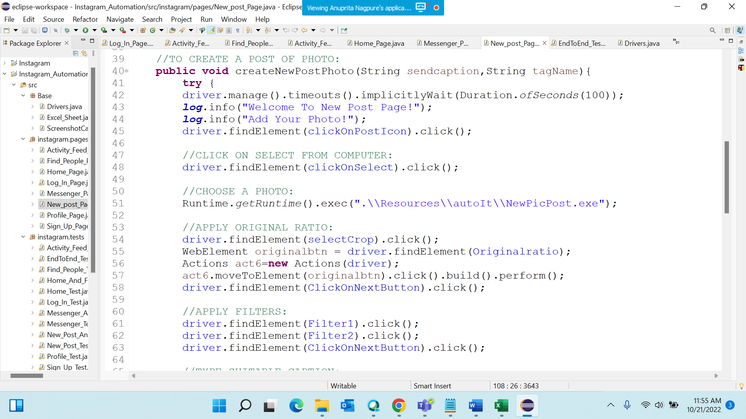

* Replace all Absolute Path with Relative Path:

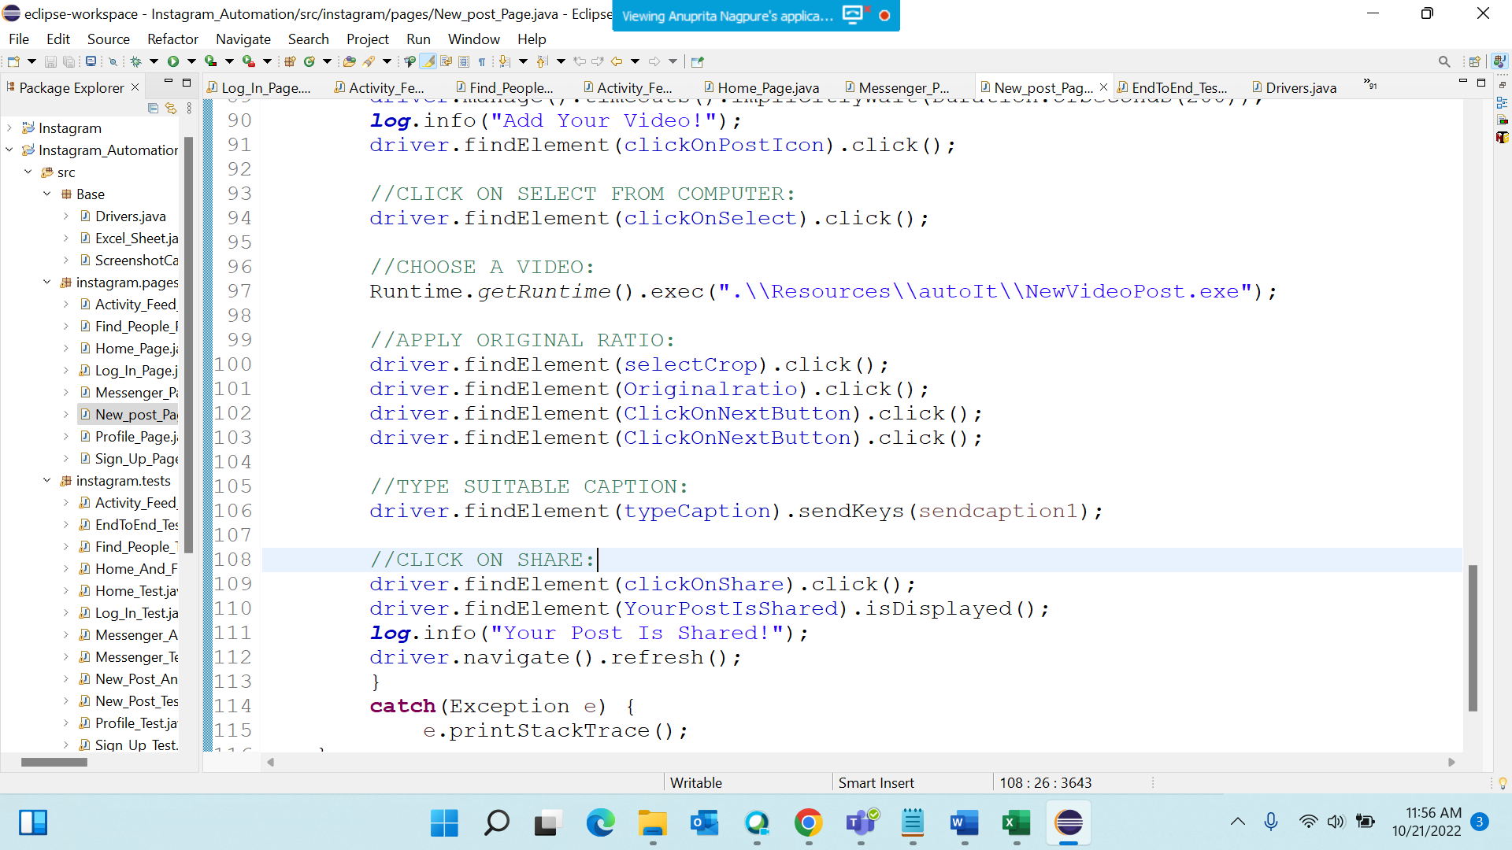

REMAINING CHANGES:

* Replace Absolute path in AutoIt Script:

Tried every possible solution for it but its not accepting any relative path:

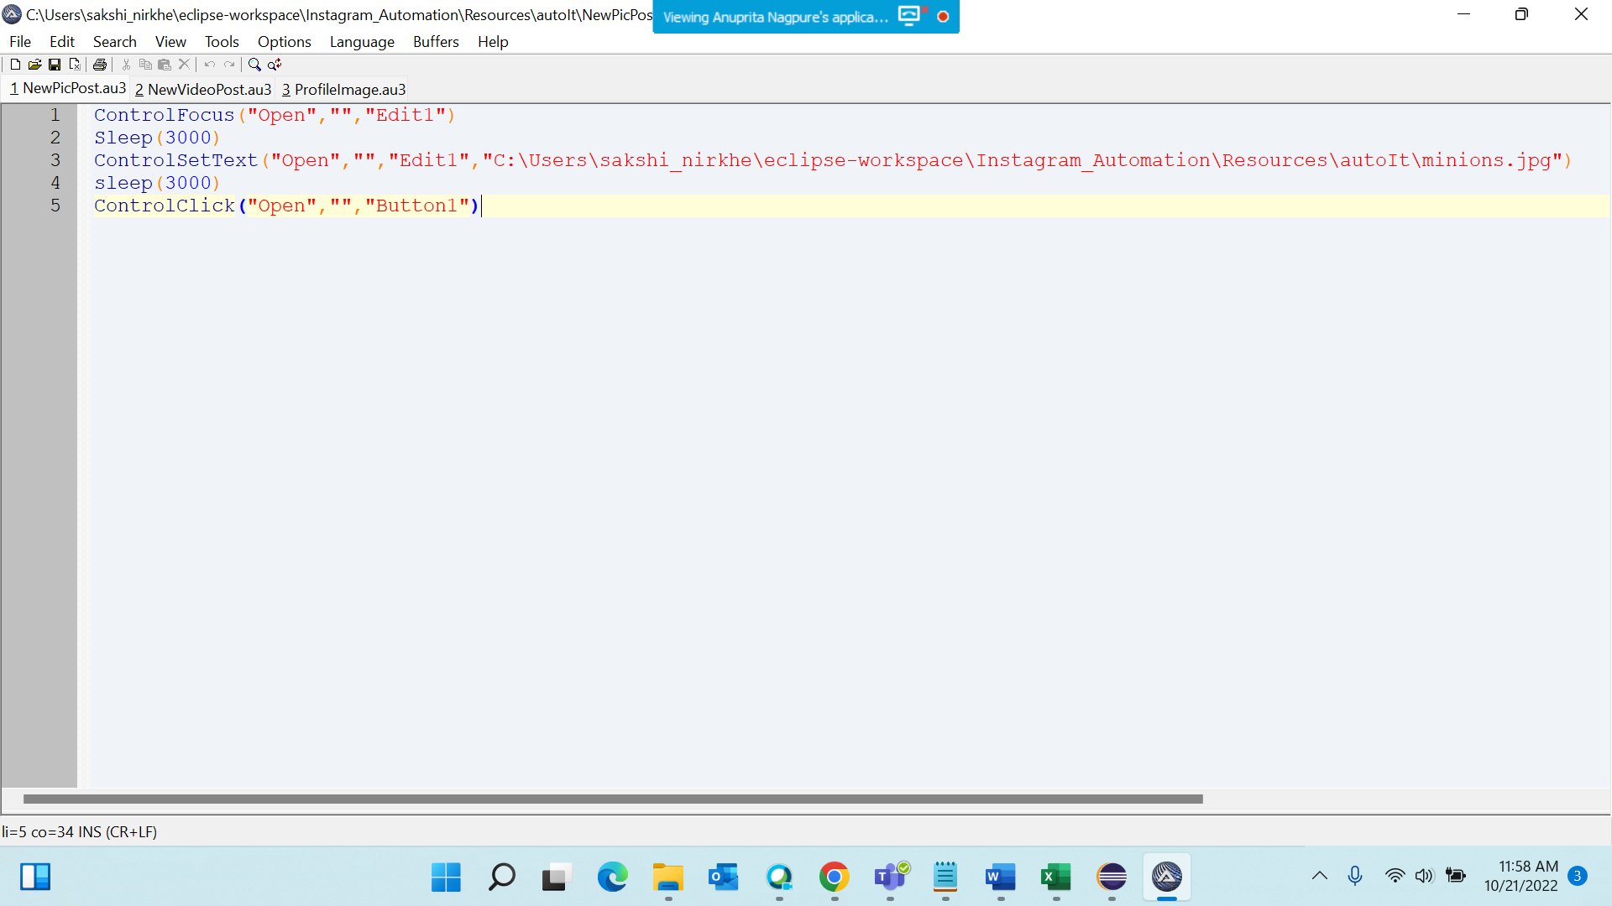

SOME EXTRA CHANGES:

* Created a Base package to store the Drivers Code, Excel Sheet Code, Error Screenshot Code:

